**GROUPING THE REQUIREMENTS**

**In order to group the requirements, first you need to switch to “GRID VIEW”**

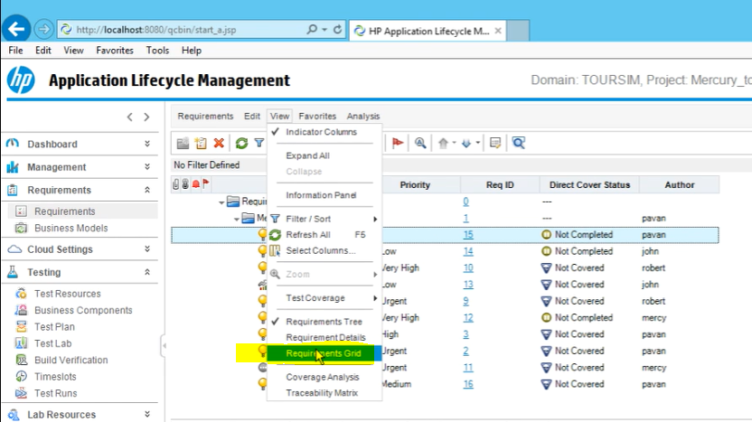

**Then, you can click on filter icon and Group option will be now available to use.**

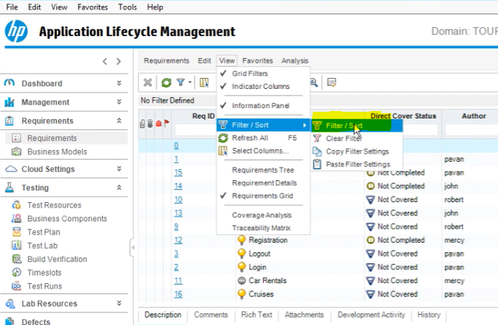

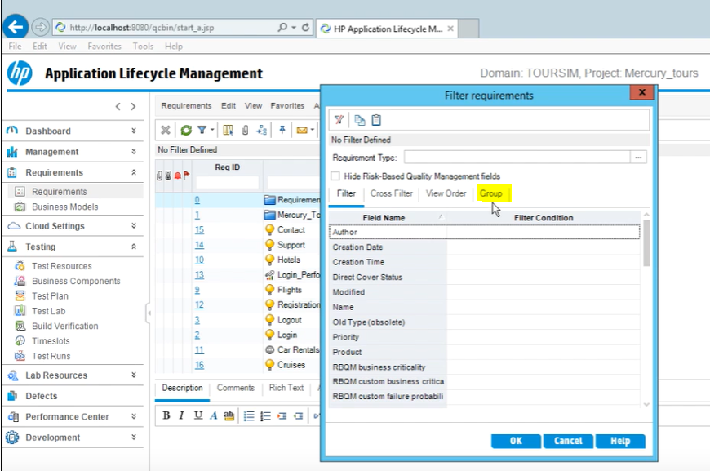

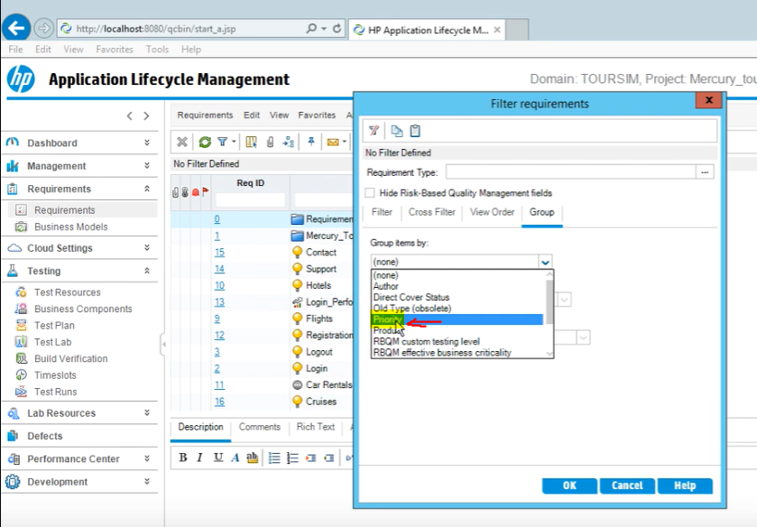

**Then click okay and it will be grouped by priority**

